Dear parents of 5th graders,
All CLI 5th graders will be having a performance “Traveling Through Africa” on Thursday, January 28th at the Broken Arrow Performing Arts Center (see times below). We will be playing instruments and some students will have speaking parts. Their artwork will also be on display in the PAC lobby for that entire week. In order for your child to have an instrument or speaking part I need to know if your child will be able to attend. Please check one of the boxes below and return to Mrs. Arthurs by Friday, January 8th.

Because there is such a large group of 5th graders, I am splitting the groups into two performances. Please email or call me with any questions you may have.

6:30pm performance time- Hutton, Thomas, Davidson, Duvall, Hansen
7:30pm performance time- Scott, Williams, Baker, Bennett, Pierce
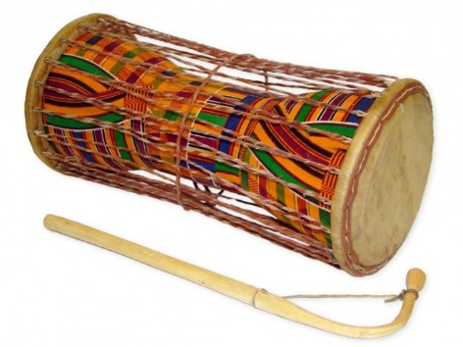

Mrs. Chase Arthurs
carthurs@baschools.org
(918) 449-5600 x251

-------------------------------------------------------DUE FRIDAY JAN 8----------------------------------------------------
- Yes, my child will attend the evening performance

- No, my child will NOT be able to attend the evening performance

_____________________________ ______________________________
Student name Teacher

